**Lattice Dynamics**

*A project report submitted by*

**Shivansh Jaiswal**

*in partial fulfilment of the requirement for the award of the degree of*

**B.Tech**



**Indian Institute of Technology Jodhpur**

**Department of Metallurgical and Materials Engineering**

*May 2022*

**Declaration**

I hereby declare that the work presented in this Project Report titled **­­­­­­­Lattice Dynamics** submitted to the Indian Institute of Technology Jodhpur in partial fulfilment of the requirements for the award of the degree of B. Tech is a bonafide record of the work carried out under the supervision of **Dr Appala Naidu Gandi.** The contents of this Project Report in full or in parts, have not been submitted to, and will not be submitted by me to, any other Institute or University in India or abroad for the award of any degree or diploma.

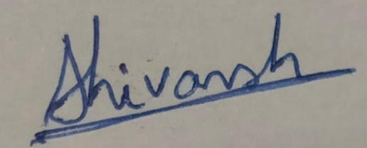

Shivansh Jaiswal

B20MT041

**Certificate**

This is to certify that the Project Report titled**­­­­­­­­­­­­ Lattice Dynamics** submitted by **Shivansh Jaiswal** to the Indian Institute of Technology Jodhpur for the award of the degree of **B. Tech**, is a bonafide record of the work done by him/her under my supervision. To the best of my knowledge, the contents of this report, in full or in parts, have not been submitted to any other Institute or University for the award of any degree or diploma.

**Signature**

Dr Appala Naidu Gandi

**Abstract**

Vesta software and understood making of a crystal lattice and representing volumetric data such as electron/nuclear densities, and crystal morphologies, monolayer representation, 2H variant, etc.

The literature survey about the topic Lattice Dynamics, understood the PHON program which gives us output in form of phonon dispersion relation, and the concepts of Lattice Dynamics.

The basic command of Linux and working of the Linux OS and performed an exercise which will be useful for better understanding of the Linux.

***Keywords***: Lattice, Vesta, Phonon, Dispersion Relation, Linux, PHON program, Phonon dispersion relation.

**TABLE OF CONTENTS**

|  |  |  |  |
| --- | --- | --- | --- |
| **Chapter No.** | **Content** | | **Page No.** |
|  | **Abstract** | |  |
|  | **List of figures** | |  |
| **1** | **INTRODUCTION AND BACKGROUND** | | **1** |
|  | * 1. **Introduction to Vesta Software**   2. **Lattice Dynamics**   3. **Introduction to Linux** | |  |
| **2** | **LITERATURE SURVEY** | | **2** |
|  | **2.1 What is Lattice Dynamics**  **2.2 Historical Aspect of Lattice Dynamics**  **2.3 Lattice Vibration**  **2.4 Why we have to study Lattice Dynamics**  **2.5 Applications of Lattice Dynamics**  **2.6 Phonons**  **2.7 Phonon Dispersion Relations**  **2.8 Force Constants and 2-nd order force constants**  **2.9 PHON program** | |  |
| **3** | **PROBLEM DEFINITION AND OBJECTIVES** | | **6** |
|  | **3.1** **Learning Vesta Software**  **3.2 Literature Survey**  **3.3 Introduction to Linux OS** | |  |
| **4** | **METHEODOLGY**  **4.1 Vesta Software**  **4.2 Literature Survey**  **4.3 Introduction to Linux OS** | | **6** |
|  |  | |  |
| **5** | **THEORETICAL/NUMERICAL/EXPERIMENTAL FINDINGS** | | **7** |
|  | * 1. **Using Vesta**   2. **In Literature**   3. **In Linux, Exercise to find the optimal lattice parameter using** | |  |
| **6** | **SUMMARY** | | **11** |
|  |  |
|  | **References** | | **11** |
|  |  | |  |

**­­­­­**

**LIST OF FIGURES**

|  |  |  |
| --- | --- | --- |
| **Figure No.** | **Title** | **Page No.** |
| Fig.1 | Crystal Lattice | 1 |
| Fig.2 | Graph between Interatomic force vs interatomic distance | 2 |
| Fig.3 | Expression for frequency | 3 |
| Fig.4 | Phonon Dispersion Relation | 3 |
| Fig.5 | Aucostic and Optical Waves | 4 |
| Fig.6 | Phonon Dispersion Relation using Optical and Aucostic Waves | 4 |
| Fig.7 | Phonon Dispersion relation for Aluminium | 4 |
| Fig.8 | Expression for 2nd order force constant | 5 |
| Fig.9 | Phonon Dispersion Relation of MgO using PHON program | 5 |
| Fig.10 | Unit Cell of GaAs | 7 |
| Fig.11 | Unit cell, atomic planes and direction | 7 |
| Fig.12 | Charge Density of NaCl structure | 7 |
| Fig.13 | Charge Density of Si | 8 |
| Fig.14 | 2 H variant of WSe2 | 8 |
| Fig.15 | Monolayer of WSe2 | 8 |
| Fig.16 | Combined Monolayer of MoSe2_WSe2 | 8 |
| Fig.17 | Expression for harmonic Potential | 9 |
| Fig.18 | Energy respective to the lattice parameter | 10 |
| Fig.19 | Graph between Lattice parameter and Energy | 10 |

**CHAPTER 1**

**INTRODUCTION AND BACKGROUND**

* 1. **Introduction to Vesta Software**

Visualization for Electronic Structural Analysis (Vesta) is a 3D visualization program for structural models, volumetric data such as electron/nuclear densities, and crystal morphologies.

It helps us to improve our visualization of the structures.

* 1. **Lattice Dynamics**

Lattice Dynamics is the Study of the vibration of the atom in a crystal lattice.  Crystal lattice dynamics is based on the concept of phonons, that is, weakly interacting waves of atomic (or ionic) vibrations and corresponding quasiparticles. A phonon is a definite discrete unit or quantum of vibrational mechanical energy, just as a photon is a quantum of electromagnetic or light energy.

A unit of vibrational energy that arises from oscillating atoms within a crystal

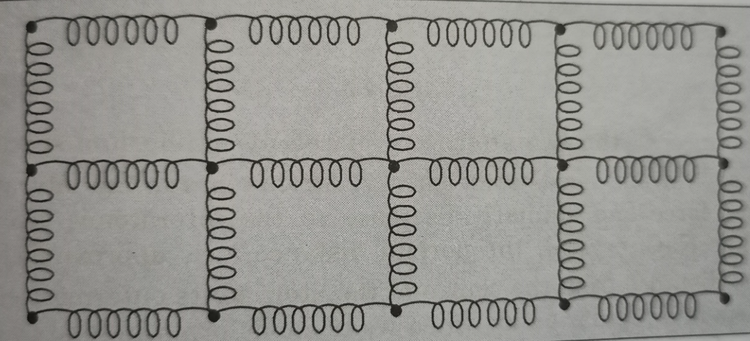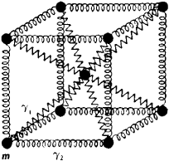

Fig. 1: Crystal Lattice

* 1. **Introduction to Linux**

Linux is an open-source operating system (OS). An operating system is the software that directly manages a system's hardware and resources, like CPU, memory, and storage.

**CHAPTER 2**

**LITERATURE SURVEY**

**2.1 What is Lattice Dynamics**

Lattice Dynamics is the Study of the vibration of the atom in a crystal lattice. Crystal lattice dynamics is based on the concept of phonons, that is, weakly interacting waves of atomic (or ionic) vibrations and corresponding quasiparticles.

**2.2 Historical Aspect of Lattice Dynamics**

The story of lattice dynamics begins in 1905, with Einstein’s confirmation, via his theory of Brownian motion, that atomic vibration really do exist.

After that many scientists had used the concept of lattice dynamics to get a better understanding at the concepts and proposed many theories for better understanding of Lattice Dynamics.

**2.3 Lattice Vibration**

Every atom has a tendency to vibrate about their mean position at temperature above zero Kelvin. The mean position is referred as the Bravais lattice site. These vibrations occur due to interatomic interactions. As the atoms in the solids are present at lattice sites, so these vibrations are called lattice vibrations. 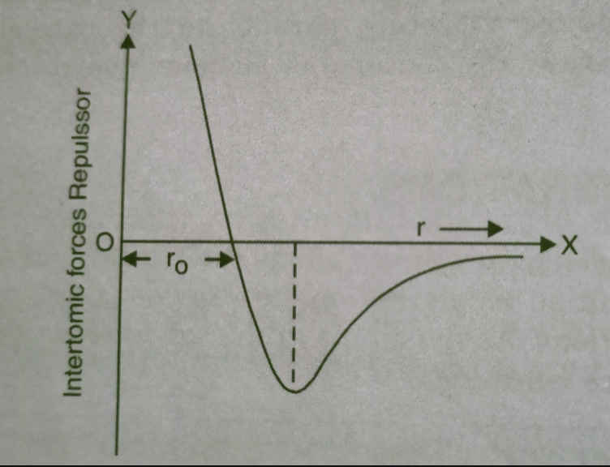

Fig. 2: Graph between Interatomic force vs interatomic distance

**2.4 Why we have to study Lattice Dynamics**

Traditional crystallography often leads to the image of atoms being held in static positions through stiff chemical bonds. Yet crystallographic measurements tell us that atoms can be vibrating with an amplitude that can be of order of 10% of an interatomic distance.

**2.5 Applications of Lattice Dynamics**

The propagation of sound waves in crystals are a practical example of the application of lattice dynamics, as also is the interaction of materials with light. For example, the absorption of certain frequencies in the infrared spectral region is directly due to the existence of specific lattice dynamics motions.

Lattice dynamics also gives us properties such as thermodynamics, superconductivity, phase transitions, thermal conductivity, and thermal expansion.

**2.6 Phonons**

A phonon is the quantum mechanical description of an elementary vibrational motion in which a lattice of atoms or molecules uniformly oscillates at a single frequency. In classical mechanics this designates a normal mode of vibration.

A packet of these waves can travel throughout the crystal with a definite energy and momentum, so in quantum mechanical terms the waves can be treated as a particle, called a phonon.

**2.7 Phonon Dispersion Relations**

The phonon dispersion relations are defined as the *k* dependence of the frequencies, ω(k,j) of the normal modes for all branches *j* and selected directions in the crystal.

For a one-dimensional alternating array of two types of ion or atom of mass *m*1, *m*2 repeated periodically at a distance *a*, connected by springs of spring constant *K*, two modes of vibration.

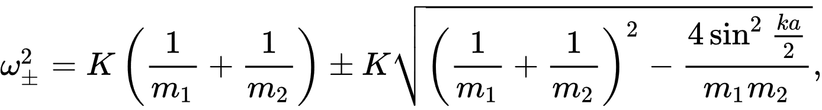

Fig.3: Expression for frequency

The connection between frequency and wavevector, *ω* = *ω*(*k*), is known as a dispersion relation. The plus sign results in the so-called *optical* mode, and the minus sign to the *acoustic* mode.

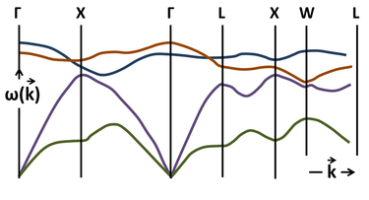

Fig.4: Phonon Dispersion relation

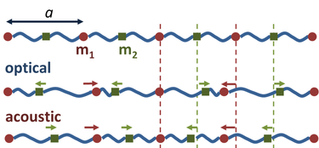 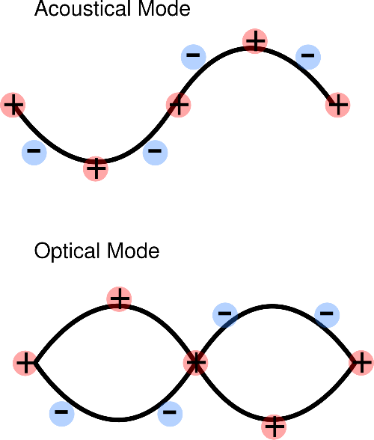

Fig.5: Aucostic and Optical Waves

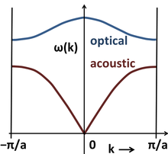

Fig.6: Phonon Dispersion Relation using Optical and Aucostic Waves

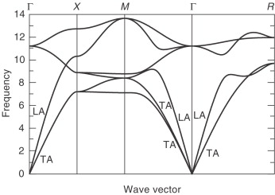

Fig.7: Phonon Dispersion relation for Aluminuim

**2.8 Force Constants and 2-nd order force constants**

A force constant defined as a second energy derivative relative to internal coordinates near the equilibrium position, Fij = d2E/dqi*dqj, is obtained most simply by the double differentiation in various points of the two-dimensional grid of qi and qj values.

Potential energy of phonon system is represented as functions of atomic positions:

The second order force constants is given by: 

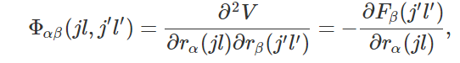

Fig.8: Expression for 2nd order force constant

**2.9 PHON Program**

* The program PHON calculates force constant matrices and phonon frequencies in crystals. From the frequencies it also calculates various thermodynamic quantities, like the Helmholtz free energy, the entropy, the specific heat and the internal energy of the harmonic crystal.
* The procedure is based on the small displacement method, and can be used in combination with any program capable to calculate forces on the atoms of the crystal. In order to examine the usability of the method, here two examples: metallic Al and insulating MgO.

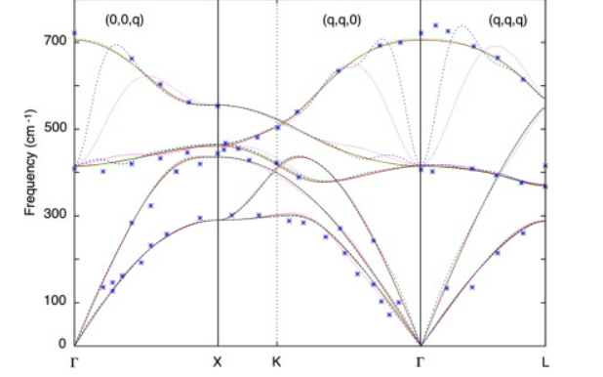

Fig.9: Phonon Dispersion Relation of MgO using the PHON program

**CHAPTER 3**

**PROBLEM DEFINATION AND OBJECTIVE**

**3.1 Learning Vesta Software**

Learn Vesta Software and make structures on it and getting familier woth the interface, making poscar, incar files and see the visual representation of charge density, 2h varient, forming a mono-layer.

**3.2 Literature Survey**

Getting familiar with the topic, reading research papers and presenting my finding on the basis of them.

**3.3 Introduction to Linux OS**

Learning basics of the linux and performing an exercise for getting familiar to the OS.

**CHAPTER 4**

**METHEODOLOGY**

**4.1 Vesta Software**

Reading the vesta module and watching vesta tutorial for construction of structures and showing properties such as charge density.

**4.2 Literature Survey**

Reading different paper’s based on lattice dynamic and phon, phonon dispersion relation, PHON

Program, and understand them.

**4.3 Introduction to Linux**

Reading the manual for linux, and practise basic operations on a linux device.

**CHAPTER 5**

**THEORETICAL/NUMERICAL/EXPERIMENTAL FINDINGS**

* 1. **Using Vesta**

**Making a unit cell : GaAs**

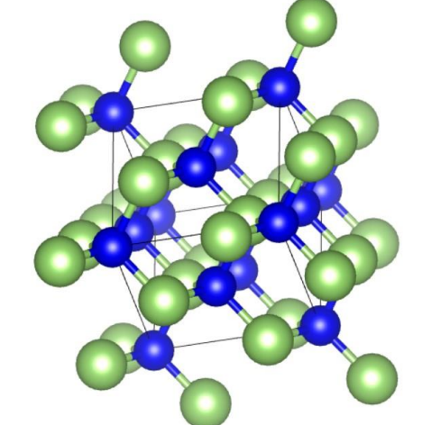

Fig.10: Unit Cell of GaAs

**Making a unit cell, atomic planes and direction**

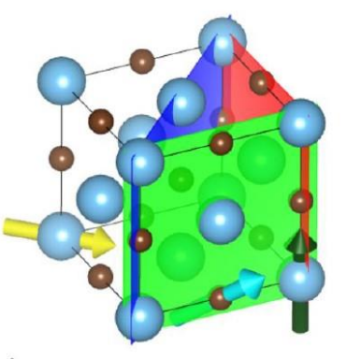 Fig.11: Unit cell, atomic planes and direction

**Charge Density of NaCl structure using vesta**

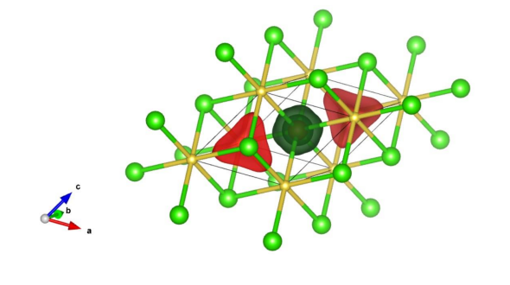

Fig.12: Charge Density of NaCl structure

**Charge density of Si atom using vesta**

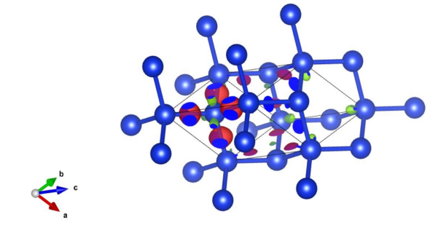

Fig.13: Charge Density of Si

**Making 2H variant Crystal of WSe2**

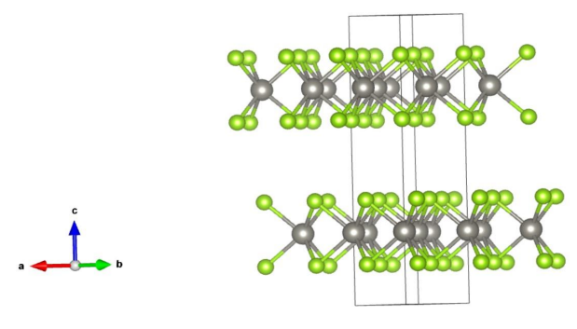

Fig.14: 2H variant Crystal of WSe2

**Monolayer formation of WSe2**

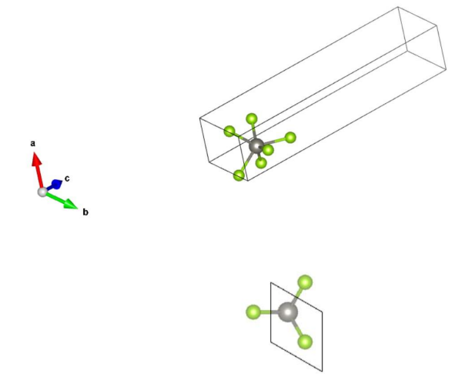

Fig.15: Monolayer of WSe2

**Combining two monolayers MoSe2_WSe2**

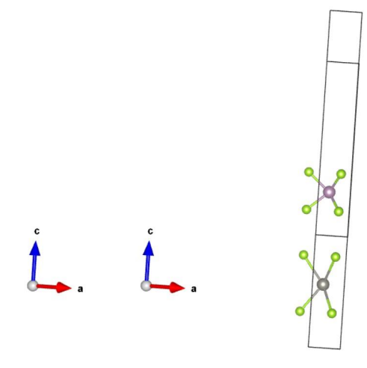

Fig.16: Combined Monolayer of MoSe2_WSe2

* 1. **In Literature**



Fig.17: Expression for harmonic Potential

* In order to calculate the energy we assume that the potentials are treated as the harmonic potentials, this assumptions is valid as long as the atoms remain close to equilibrium position.
* The expression for potential is obtained by using the Taylor's expansion and we found that the potential is proportional to displacement square and gives the quadratic term.
* Higher order terms are neglected as we as assuming the displacement about there mean position to be less.

**Understanding the expression in depth**

* Consider a solid consisting of  N atoms, each of mass mi,  with position  ri. The equilibrium position is ri0 .Each atom can vibrate about its equilibrium position. The displacement from the equilibrium position 
* Since the displacements are small, we can expand the potential energy taylor’s  series: 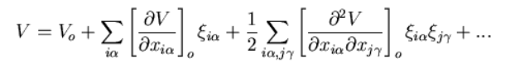
* In the expression I and j go from 1 to n; and alpha and gamma go from 1 to 3.
* The derivatives are evaluated at the equilibrium positions of atoms.
* The first term Vo is the potential energy when the atoms are in their equilibrium configuration. 
* Since Vo is the minimum value of V the first derivative must be equals to zero.
* That is there is no force on any atom in the equilibrium configuration. So the first term in the Taylor series vanishes and we get the expression 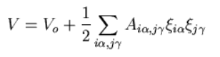It can also be given as:



**5.3 In Linux, Exercise to find the optimal lattice parameter using Linux**

The exercise was to find the optimal lattice parameter for which we can get the optimal energy.

For this, we used the formula:

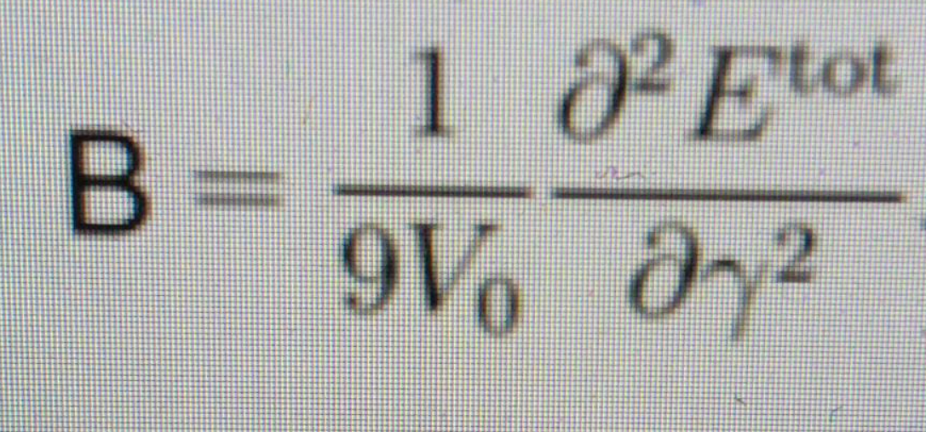

We used the Linux operation and a Linux software which will find and gnuplot for plotting the curve between Lattice parameter and energy.

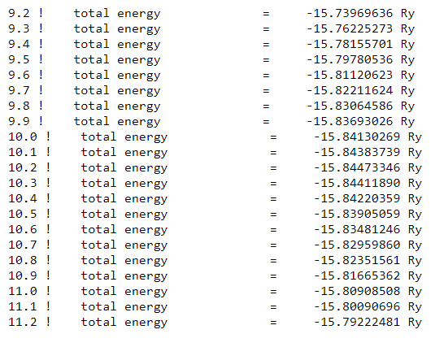

Fig.18: Energy respective to the lattice parameter

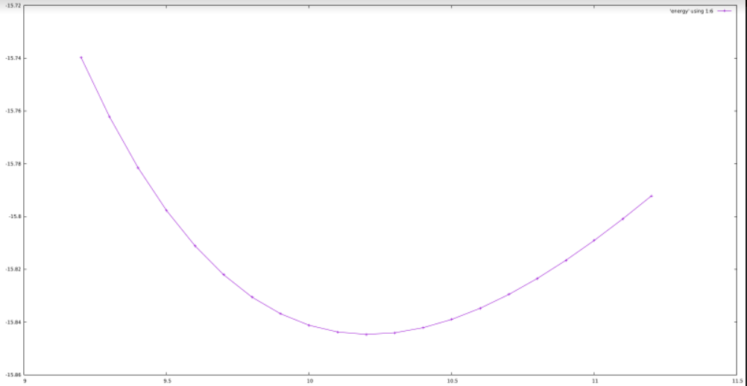

Fig.19: Graph between Lattice parameter and Energy

By the graph we can conclude that the optimal lattice parameter is 10.2(approx.)

**CHAPTER 6**

**SUMMARY**

Using Vesta software forming different unit cell and shown many volumetric data such as electron/nuclear densities, and crystal morphologies, monolayer representation, 2H variant, etc.

Literature survey for lattice dynamics Understanding the concepts in depth and understanding the PHON program which helps us to find the phonon dispersion relation.

Using Linux finding the optimal Lattice parameter and understood the basic functioning of the Linux OS.

**CHAPTER 7**

**REFERENCES**

* + Article on Science direct webpage about lattice Dynamics

Link: <https://www.sciencedirect.com/topics/chemistry/lattice-dynamics#:~:text=Introduction,be%20described%20as%20a%20particle>).

* + Introduction to Lattice Dynamics Book by Martin T. Dove
  + Lattice Dynamics Book by A.A. Maradudin
  + Article on Neuro Science website

Link: <https://www.neutron-sciences.org/articles/sfn/pdf/2011/01/sfn201112007.pdf>

* Wikipedia
* Artice on Phonon Dispersion relation

Link : <https://www.sciencedirect.com/topics/engineering/phonon-dispersion>

* Vesta learning module

Link : <https://vestaevv.com/wp-content/uploads/2021/12/Vesta-Learning-Management-System.pdf>

* Linux learning module Basics of linux

Link: <https://www.hostinger.in/tutorials/linux-commands>

* Introduction to solid state Book by Charles Kittles